Name:
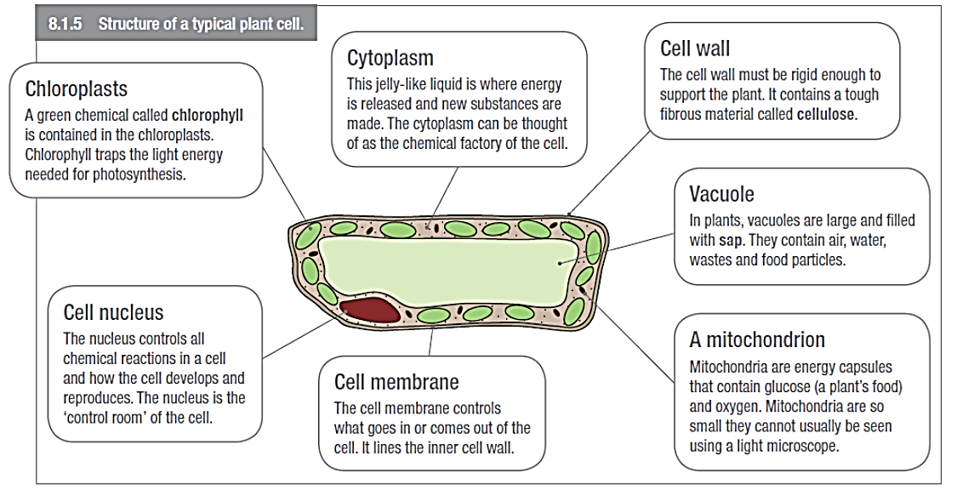
Use your text book to complete the information in the boxes:

ScienceWays Book 1 page 202

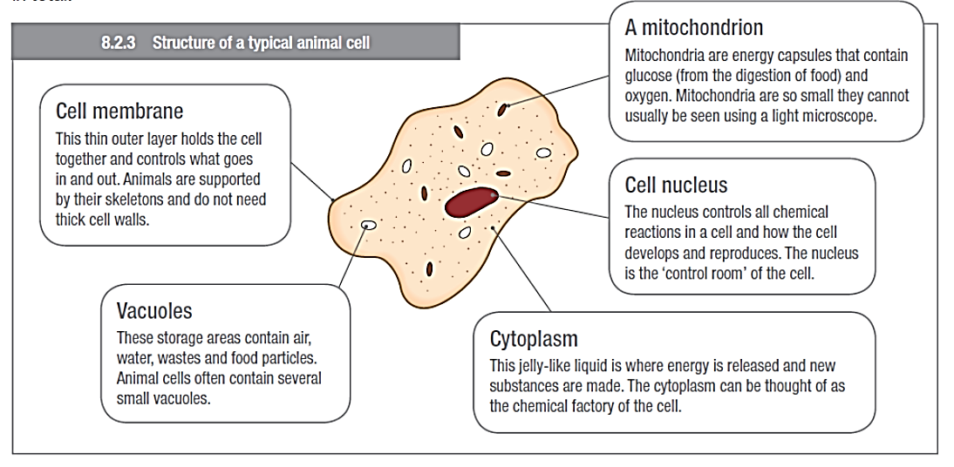

ScienceWays Book 1 page 209

